**EVO 3 Web Platform**

**User Manual**

**Revision 1.0**

**Document History and Version Control**

|  |  |  |
| --- | --- | --- |
| **Version** | **Date** | **Description** |
| 1.00 | 14 July 2015 | Creation of the document |
|  |  |  |
|  |  |  |
|  |  |  |

Table of Contents

System Requirement 4

Deployment of solution to work with EVO 3 5

Operation 14

Main Page 14

Setting Page 15

Barcode 16

2D Code 22

OCR 28

Measurement Page 36

Circle Measurement Page 38

Distance Measurement: Point to Circle Page 42

Distance Measurement: Circle to Line Page 43

Distance Measurement: Circle to Circle Page 43

Distance Measurement: Point to Point Page 44

Distance Measurement: Point to Line Page 44

Width Measurement Page 45

# System Requirement

* Processor starting with a Pentium 3 – 800 MHz
* A minimum of 512 MB RAM approx. 500MB free space on your hard disk
* High colour graphic adapter (16 Bit) with a minimum resolution of 1366 x 768 or more
* Operating System:
* Microsoft Windows XP starting with Service Pack 2
* Apple IOS (mobile) version 5.1.1 and above
* Android version 4.4.2 KitKat and above
* Web browser:
* Google chrome version 24.0.1312.52m and above
* Mozilla Firefox version 39.0 and above
* Safari (mobile)

# Deployment of solution to work with EVO 3

Copy whole solution to “C:\temp\wwwroot” (create wwwroot folder if it does not exist)

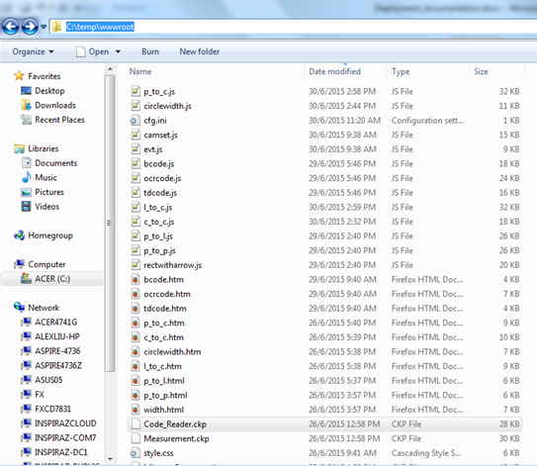

It is required to put your ckp file into the default Evo3 programs folder.

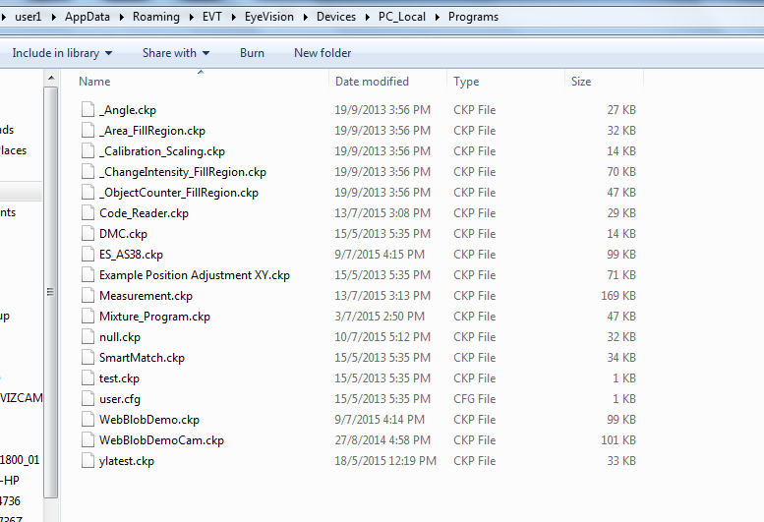

* Open “SmartBuilder Evo3” application
* Select “Open program”
* Select “measurement.ckp” or “code_reader.ckp” to load the tools which were preset

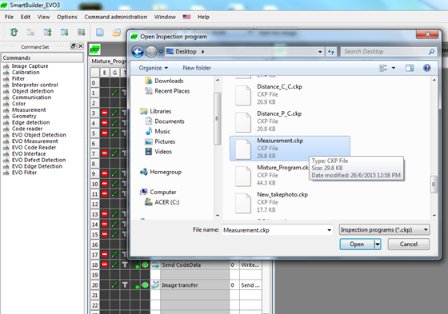

* Select “Options”, “Application parameters”, “ProgramControl”
* Enable “Ini”,”TCP”, “UDP” and “Web server” by setting “Enabled” to “1”.

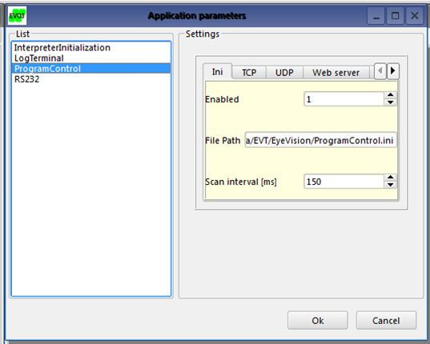

Under “Web server” tab, set the following parameters accordingly:

* Port to “8080”
* Maximum file size for sending to “499999” (maximize the sending file size)
* File Path for wwwroot folder to “C:\temp\wwwroot” (which was created in the previous step)

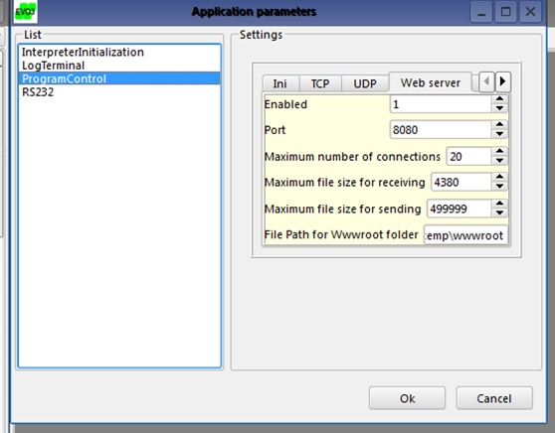

Open up the web browser and go to http://<your ip address>:8080/index.htm (in this case I’m using 192.168.66.6)

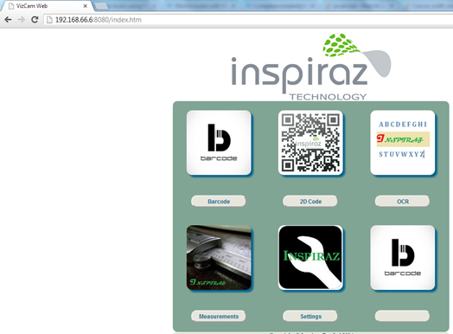

In order for the web to load images from the EVO 3 applications. Image transfer must set accordingly. By having this setting, this will allow it to upload images to a cache folder call “snapshot” for the web to retrieve the images from the cache folder.

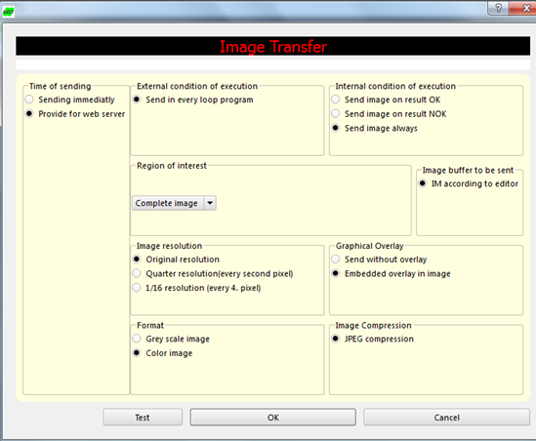

In order to receive the result from Evo3 software, it is necessary to put INI File Access command in the ckp file and configure as follows:

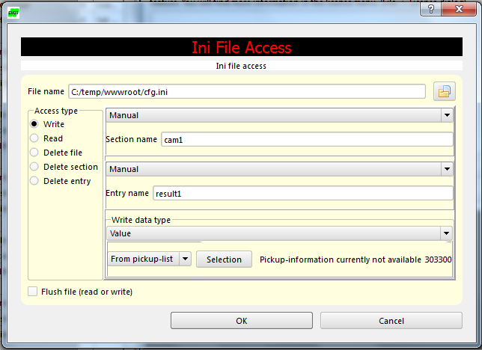

In order to receive the result for Code (Barcode, 2D Code and OCR). These three commands are required to add in.

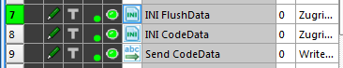

The settings are as follows:

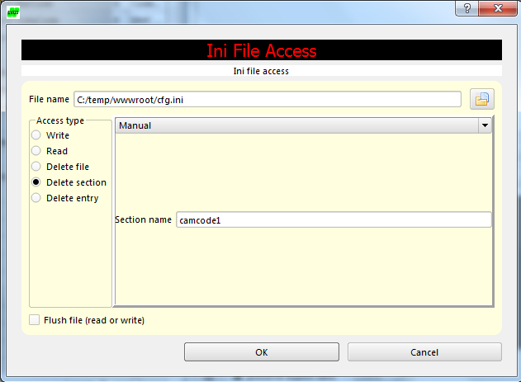

Settings for INI Flushdata

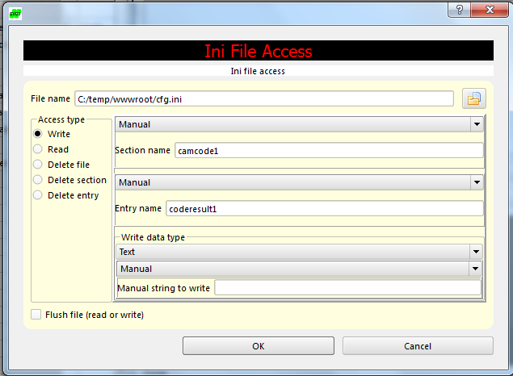

Settings for INI CodeData

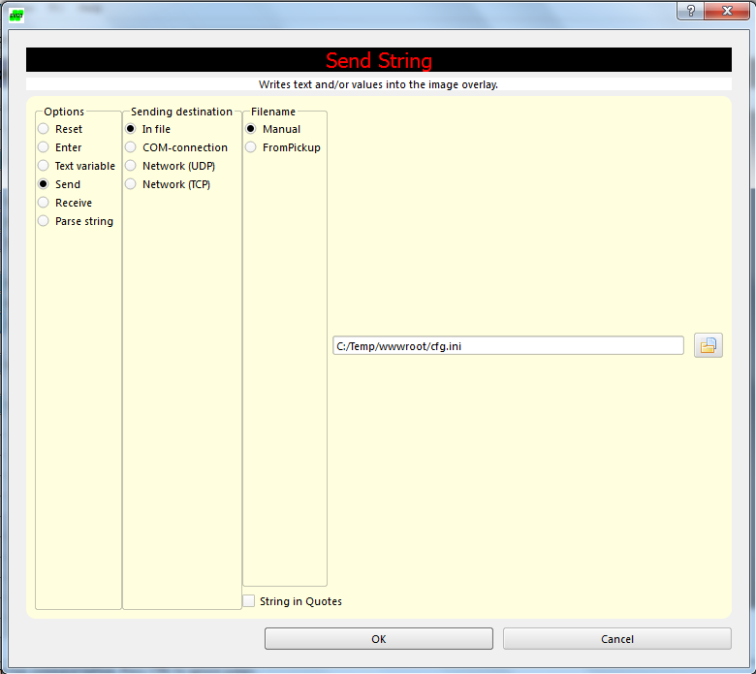

Settings for Send CodeData

# Operation

## Main Page

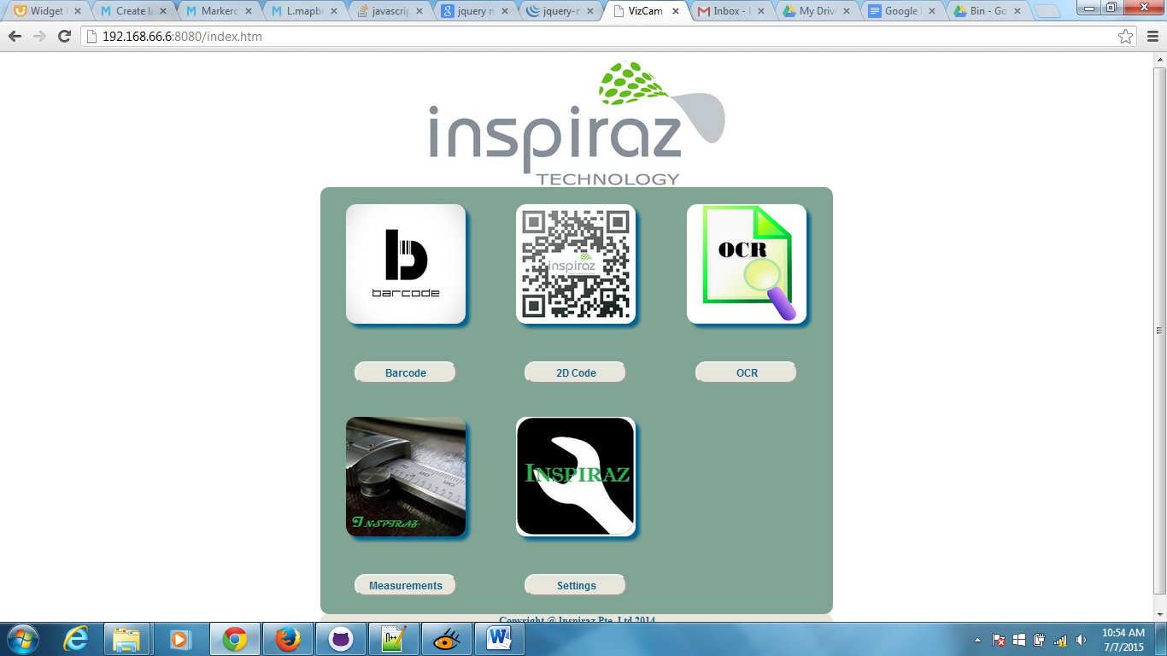

|  |  |
| --- | --- |
| **Number** | **Description** |
| 1 | Access to Barcode page |
| 2 | Access to 2D Code page (DMC, QR, Micro QR) |
| 3 | Access to OCR page |
| 4 | Access to Measurement page (Circle, Width, Distance) |
| 5 | Access to Settings page |

## Setting Page

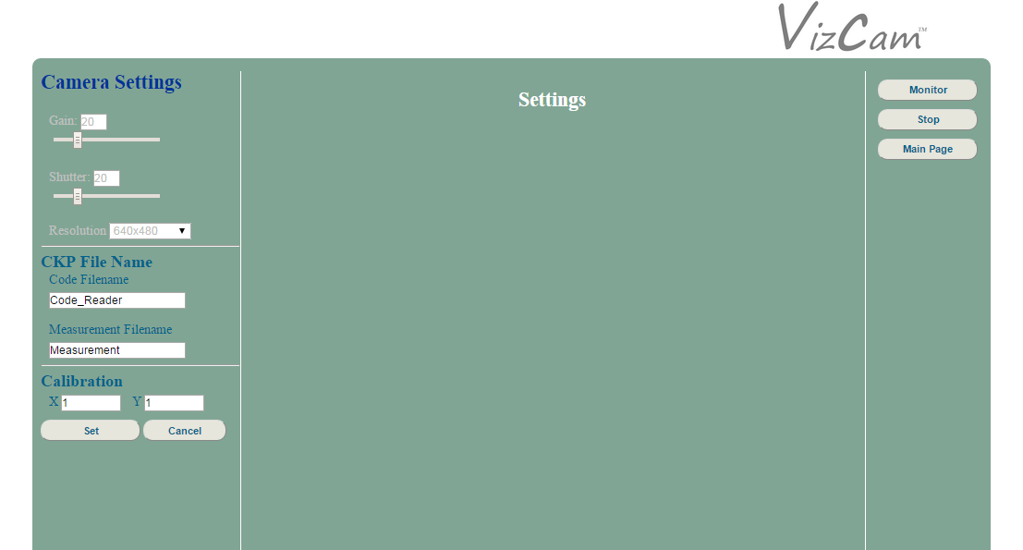

|  |  |
| --- | --- |
| **Number** | **Description** |
| 1 | Specify the ckp filenames that is required to change. Default filenames for code and measurement are “Code_Reader” and “Measurement” respectively. |
| 2 | Specify the calibration if there is calibration command in your ckp file. If there is no calibration, leave it as 1 for both X and Y. |

## Barcode

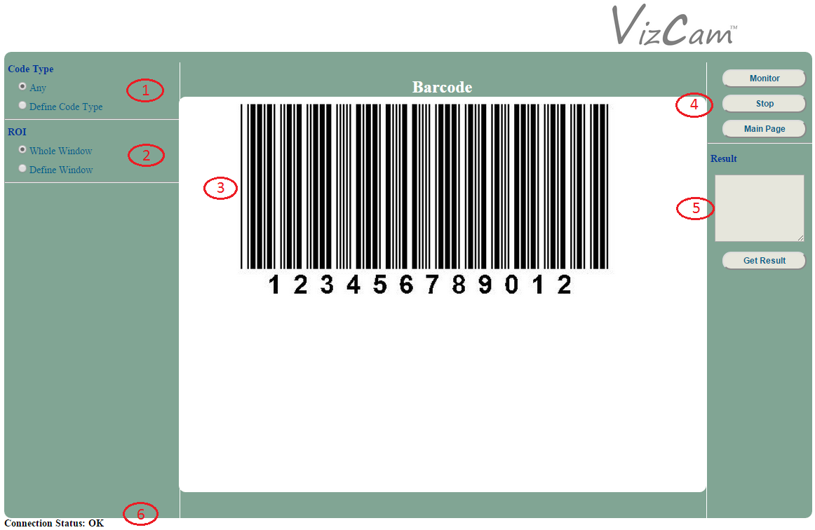

|  |  |
| --- | --- |
| **Number** | **Description** |
| 1 | Selection of the code type |
| 2 | Selection of the region of interest (ROI) |
| 3 | Canvas area that displays the capture of the camera |
| 4 | Main buttons to start or stop the capture of the camera and to return to the main page |
| 5 | Display area which displays the results |
| 6 | Status of the camera connection |

**1. Code Type**

* Any

Select this option to allow the barcode reader to check through all the possible barcode types.

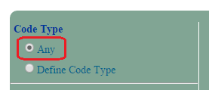

* Define Code Type

Select this option to reveal a drop-down list which allows the selection of a specific barcode type for the barcode reader to use.

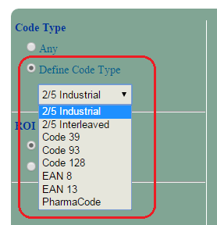

**2. ROI**

* Whole Window

Select this option to set the region of interest (ROI) as the complete image.

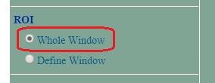

* Define Window

Select this option to define a specific region of interest (ROI).

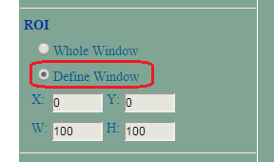

Use the provided probe on the image to set the desired ROI.

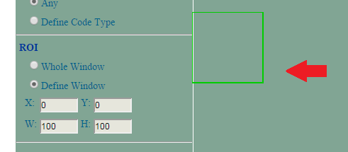

The size and the coordinates of the probe are displayed in their respective display boxes.

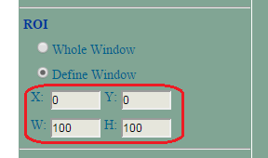

**3. Canvas Area**

The view of the camera is displayed in the canvas area.

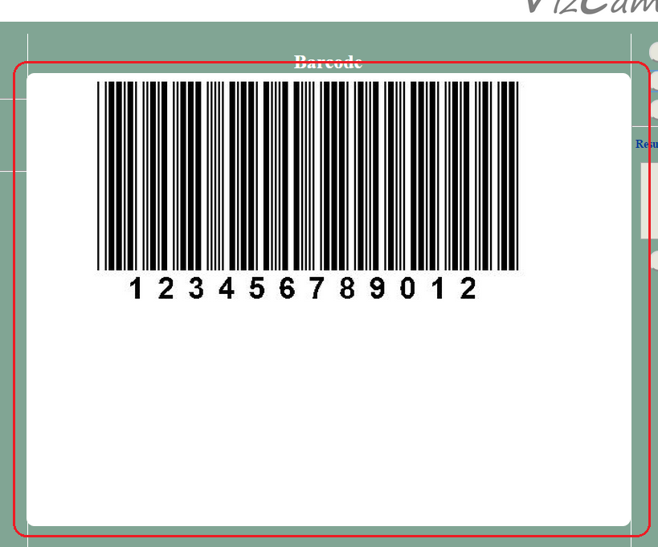

**4. Main Buttons**

* Click on the “Monitor” button to start the camera capture.

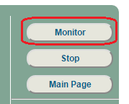

* Click on the “Stop” button to stop the camera capture.

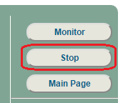

* Click on the “Main Page” button to return to the main page.

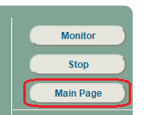

**5. Results**

The result of the barcode reader is displayed in its display box after clicking on the “Get Result” button.

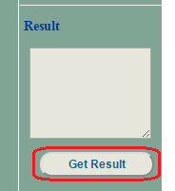

**6. Connection Status**

The connection status is displayed after the “Monitor” button has been clicked. Depending on the state of the connection, it will either display:

* OK

This means that there is still transmission received from the camera.

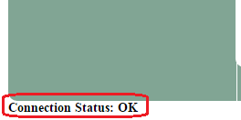

* Timeout

This means that there is no transmission received from the camera.

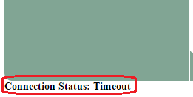

## 2D Code

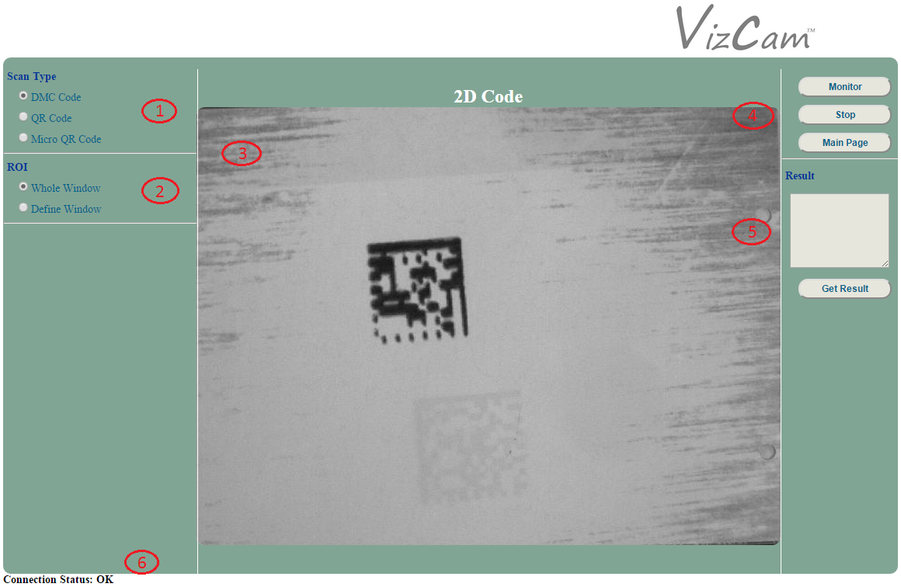

|  |  |
| --- | --- |
| **Number** | **Description** |
| 1 | Selection of the type of code for scanning |
| 2 | Selection of the region of interest (ROI) |
| 3 | Canvas area that displays the capture of the camera |
| 4 | Main buttons to start or stop the capture of the camera and to return to the main page |
| 5 | Display area which displays the results |
| 6 | Status of the camera connection |

**1. Scan Type**

* DMC Code

Select this option to allow the 2D code reader to scan for DMC code only.

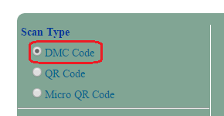

* QR Code

Select this option to allow the 2D code reader to scan for QR code only.

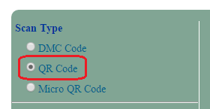

* Micro QR Code

Select this option to allow the 2D code reader to scan for Micro QR code only.

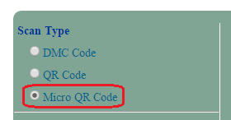

**2. ROI**

* Whole Window

Select this option to set the region of interest (ROI) as the complete image.



* Define Window

Select this option to define a specific region of interest (ROI).



Use the provided probe on the image to set the desired ROI.

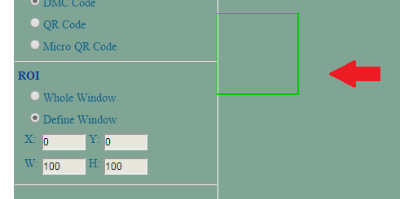

The size and the coordinates of the probe are displayed in their respective display boxes.



**3. Canvas Area**

The view of the camera is displayed in the canvas area.

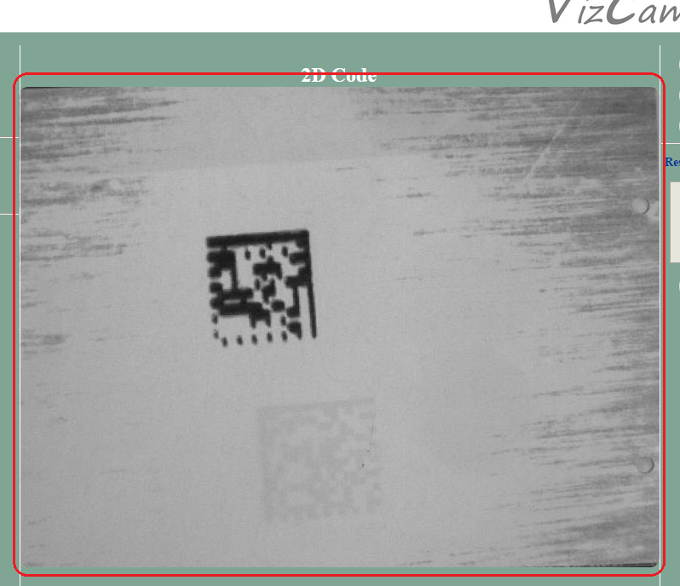

**4. Main Buttons**

* Click on the “Monitor” button to start the camera capture.



* Click on the “Stop” button to stop the camera capture.



* Click on the “Main Page” button to return to the main page.



**5. Results**

The result of the 2D code reader is displayed in its display box after clicking on the “Get Result” button.



**6. Connection Status**

The connection status is displayed after the “Monitor” button has been clicked. Depending on the state of the connection, it will either display:

* OK

This means that there is still transmission received from the camera.



* Timeout

This means that there is no transmission received from the camera.



## OCR

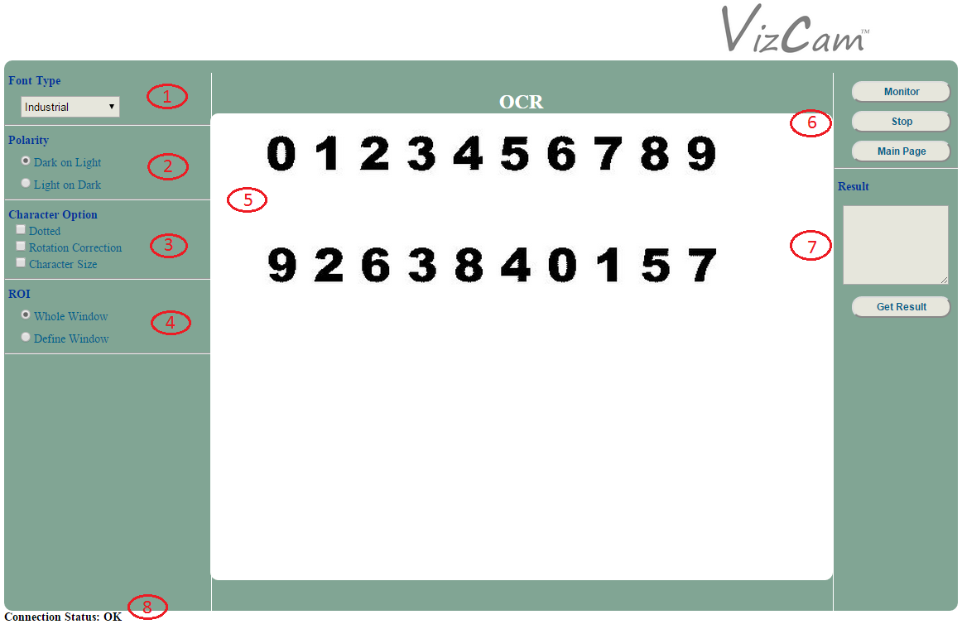

|  |  |
| --- | --- |
| **Number** | **Description** |
| 1 | Selection of the type of font |
| 2 | Selection of the type of polarity |
| 3 | Selection of the character options |
| 4 | Selection of the region of interest (ROI) |
| 5 | Canvas area that displays the capture of the camera |
| 6 | Main buttons to start or stop the capture of the camera and to return to the main page |
| 7 | Display area which displays the results |
| 8 | Status of the camera connection |

**1. Font Type**

Select a specific font type for the OCR reader to use.

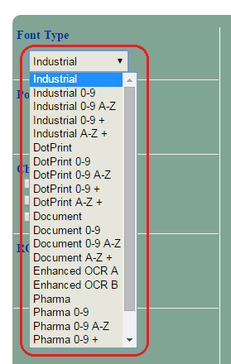

**2. Polarity**

* Dark on Light

Select this option to set the polarity as dark text on a light background.

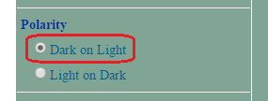

* Light on Dark

Select this option to set the polarity as light text in a dark background.

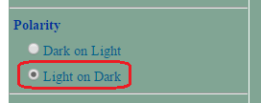

**3. Character Option**

* Dotted

Select this option to set character as dotted.

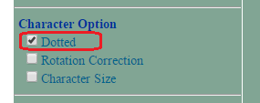

* Rotation Correction

Select this option to enable rotation correction.

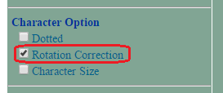

* Character Size

Select this option to define a specific character size.

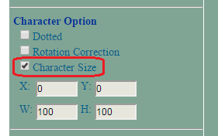

Use the provided probe on the image to set the desired character size.

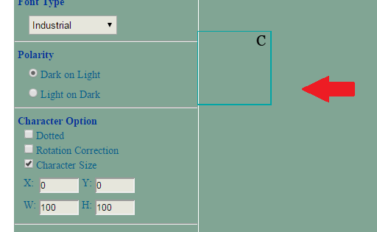

The size and the coordinates of the probe are displayed in their respective display boxes.

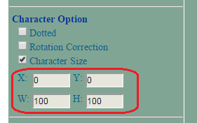

**4. ROI**

* Whole Window

Select this option to set the region of interest (ROI) as the complete image.



* Define Window

Select this option to define a specific region of interest (ROI).



Use the provided probe on the image to set the desired ROI.

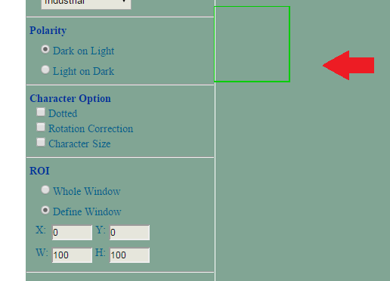

The size and the coordinates of the probe are displayed in their respective display boxes.



**5. Canvas Area**

The view of the camera is displayed in the canvas area.

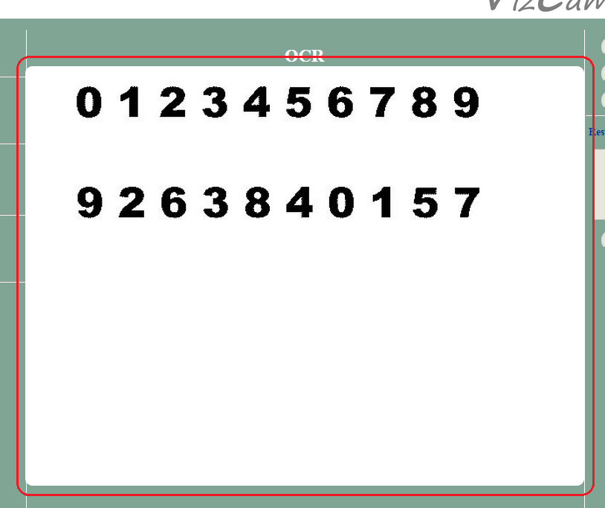

**6. Main Buttons**

* Select the “Monitor” button to start the camera capture.



* Select the “Stop” button to stop the camera capture.



* Select the “Main Page” button to return to the main page.



**7. Results**

The result of the OCR reader is displayed in its display box after clicking on the “Get Result” button.



**8. Connection Status**

The connection status is displayed after the “Monitor” button has been clicked. Depending on the state of the connection, it will either display:

* **OK**

This means that there is still transmission received from the camera.



* **Timeout**

This means that there is no transmission received from the camera.



## Measurement Page

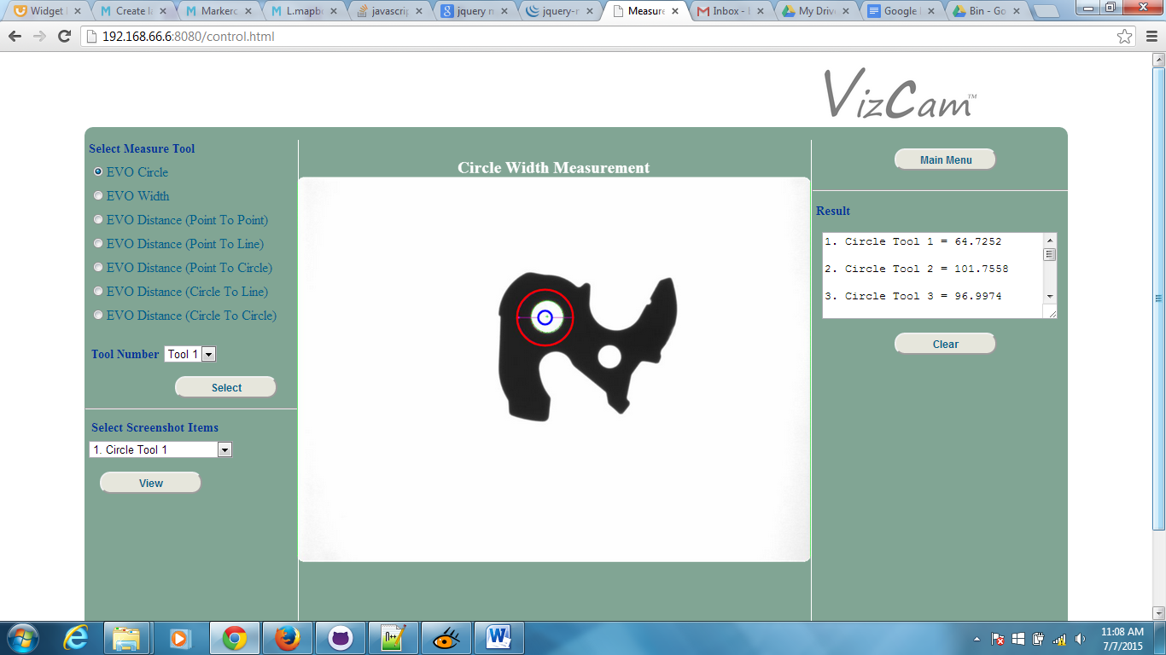

|  |  |
| --- | --- |
| **Number** | **Description** |
| 1 | Select the measuring tool on measuring the **Circle diameter**, **Width**, **Point to Point**, **Point to Line**, **Point to Circle**, **Circle to Line** and **Circle to Circle**. |
| 2 | This allows each measuring tools to do a maximum of 8 measurements. |



|  |  |
| --- | --- |
| **Number** | **Description** |
| 1 | Select the measurement screenshot which captured by the system to view. |
| 2 | Display the screenshot image upon selecting the screenshot items to display. |



|  |  |
| --- | --- |
| **Number** | **Description** |
| 1 | **Main Menu** - Back to main page |
| 2 | **Result** - Display the measurement results |
| 3 | **Clear** - All existing measurement results will be wiped off from the system when this button is clicked. |

### Circle Measurement Page

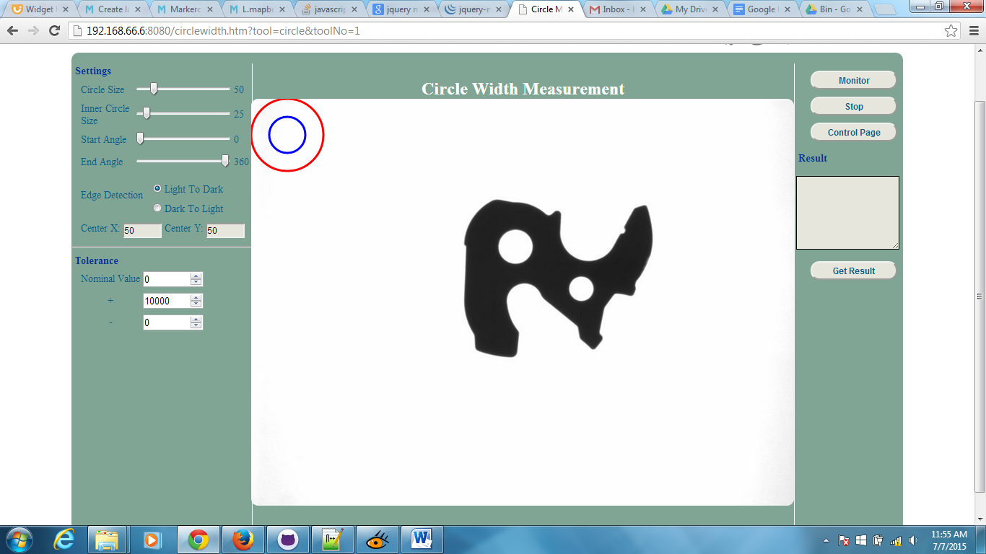

|  |  |
| --- | --- |
| **Number** | **Description** |
| 1 | Measuring tool to select a certain point to measure on. |
| 2 | Display live image from the EVO3 and this can be made to view live images from the camera where it depends on the settings on EVO3. |

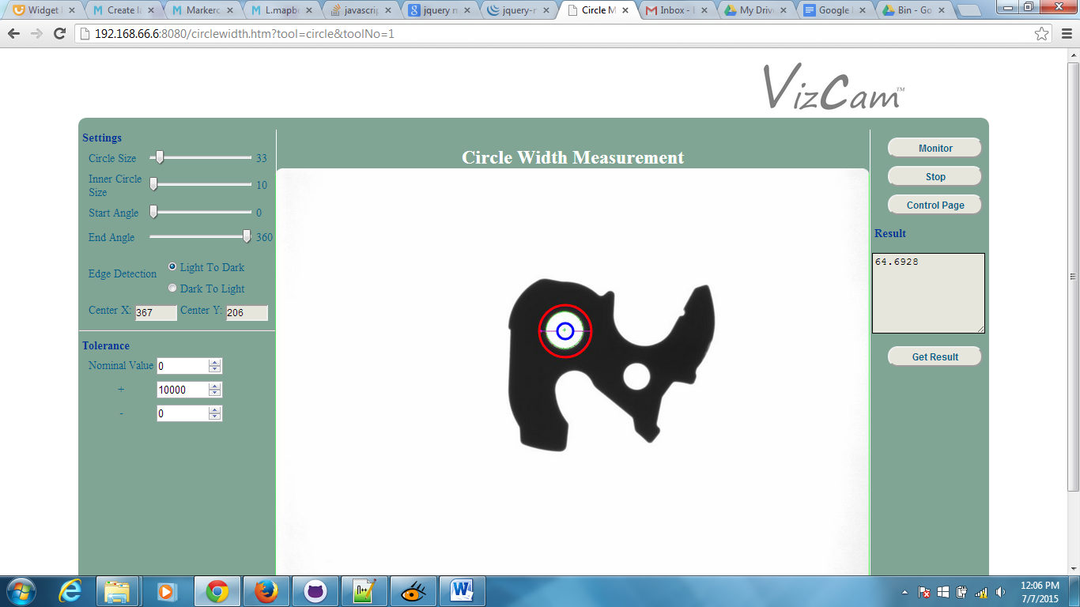

|  |  |
| --- | --- |
| **Number** | **Description** |
| 1 | **Monitor** - Start getting live image from the camera and display on screen. |
| 2 | **Stop** - Stop getting live image from the camera |
| 3 | **Control Page** - Back to control page |
| 4 | **Get Result** - Get measurements on the specific points by the users |
| 5 | **Result** - Display measurement results |

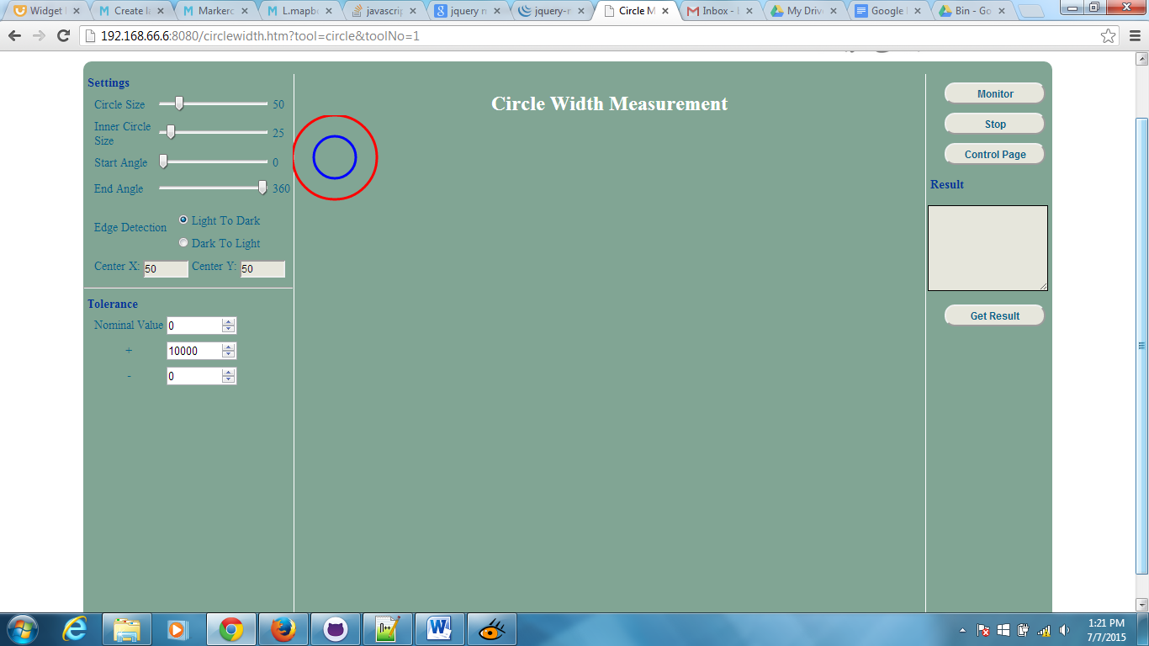

|  |  |
| --- | --- |
| **Number** | **Description** |
| 1 | Adjust the setting for the circle  **Circle Size** – adjust the size of the outer radius of the circle  **Inner Circle Size** – adjust the size of the radius of the inner circle  **Start Angle** – adjust the start angle of the circle to specify the point it should start  **End Angle** – adjust the end angle of the circle to specify the point it should end |
| 2 | **Edge Detection** - To select the edge if it is from light to dark or dark to light, as this will affect the system to be able to detect the edge and measure.  **light to dark** - Edges that are changing from light to dark are counted and displayed  **dark to light** - Edges that are changing from dark to light are counted and displayed |
| 3 | Display the X & Y coordinates of the centre point of the circle. |
| 4 | **Tolerance** - Set point and modify both positive or negative to determine the range which allows the system to determine if the result is OK or NOK (Not OK). |
| 5 | A circle tool to specify the Region of Interest (ROI) to do the measurement. |

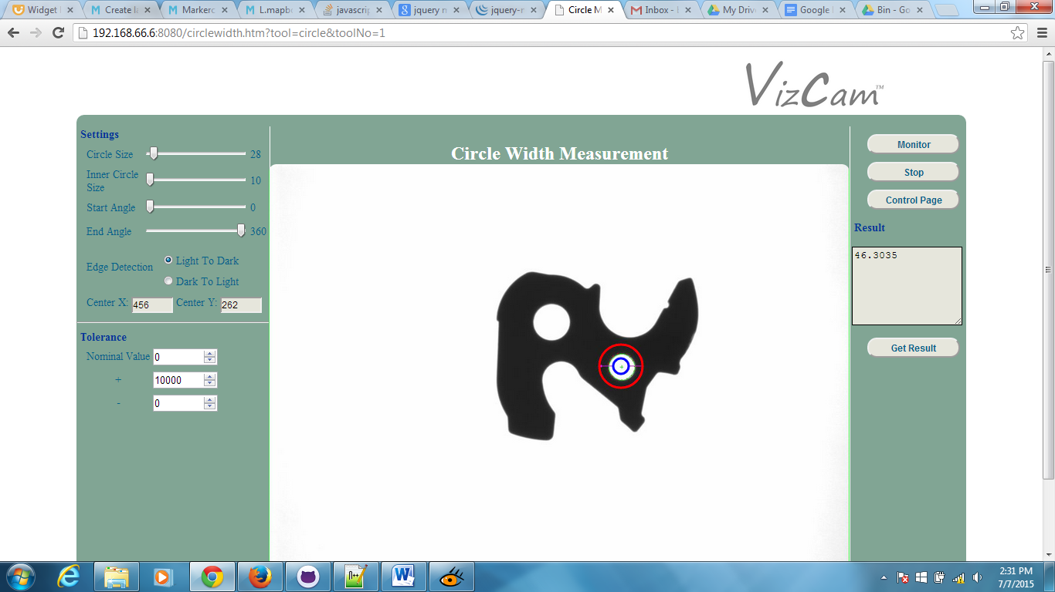Above image shows the example to measure the circle diameter.

### Distance Measurement: Point to Circle Page

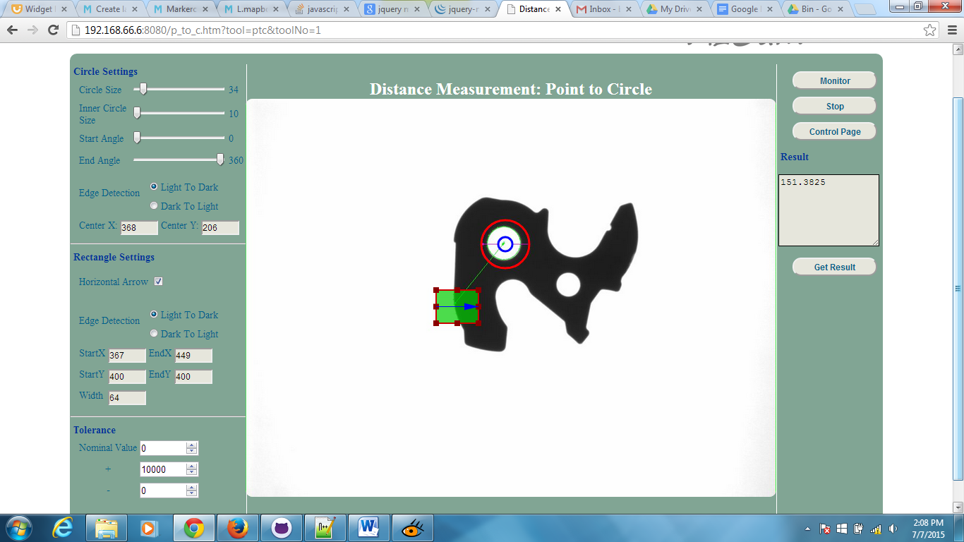

|  |  |
| --- | --- |
| **Number** | **Description** |
| 1 | **Horizontal Arrow** - This option allows the rectangle to rotate horizontal or vertical. If checkbox is uncheck it rotates to vertical and vice versa. |
| 2 | Display rectangle start X & Y, end X & Y coordinates and width of the rectangle. |
| 3 | Above image shows the example to do the measurement on point to circle. (Note that the arrow will have to face the direction which wants to measure) |

### Distance Measurement: Circle to Line Page

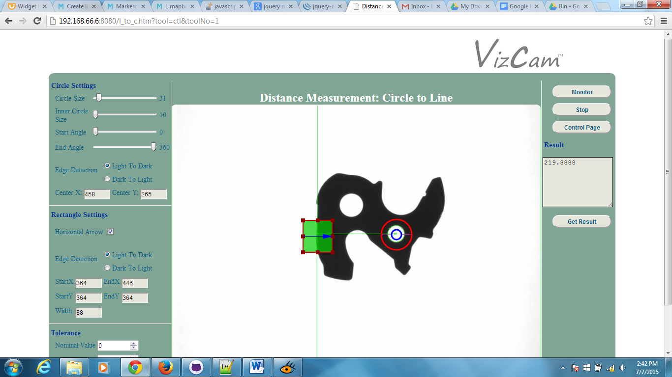

|  |  |
| --- | --- |
| **Number** | **Description** |
| 1 | Adjustment for circle settings |
| 2 | Adjustment for rectangle box settings |
| 3 | Above image shows the example to do the measurement on line to circle.  (Note that the arrow will have to face the direction which wants to measure) |

### Distance Measurement: Circle to Circle Page

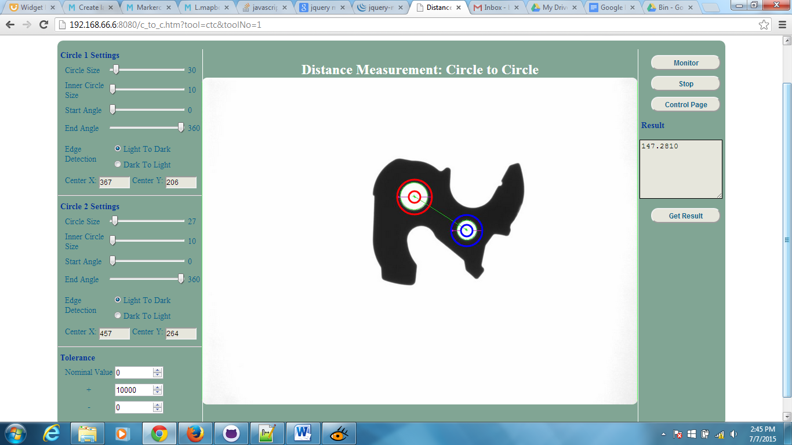

|  |  |
| --- | --- |
| **Number** | **Description** |
| 1 | Adjustment for circle 1 (red) settings |
| 2 | Adjustment for circle 2 (blue) settings |
| 3 | Above image shows the example to do the measurement on circle to circle. |

### Distance Measurement: Point to Point Page

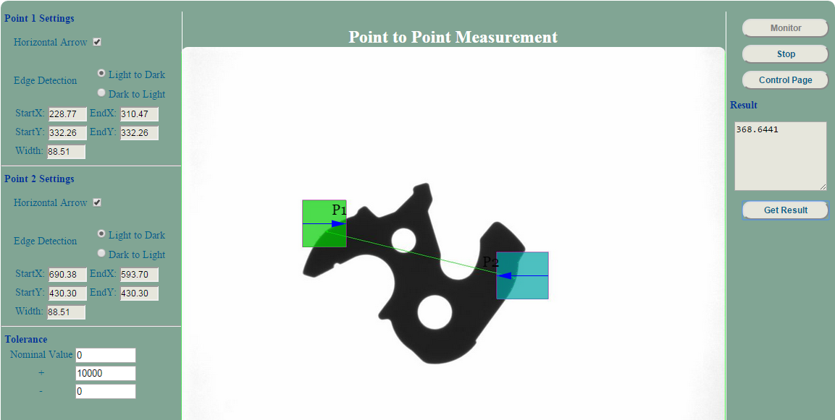

|  |  |
| --- | --- |
| **Number** | **Description** |
| 1 | Adjustment for point 1 settings |
| 2 | Adjustment for point 2 settings |
| 3 | Above image shows the example to do the measurement from point1 to point2. (Note that the arrow will have to face the direction which wants to measure) |

### Distance Measurement: Point to Line Page

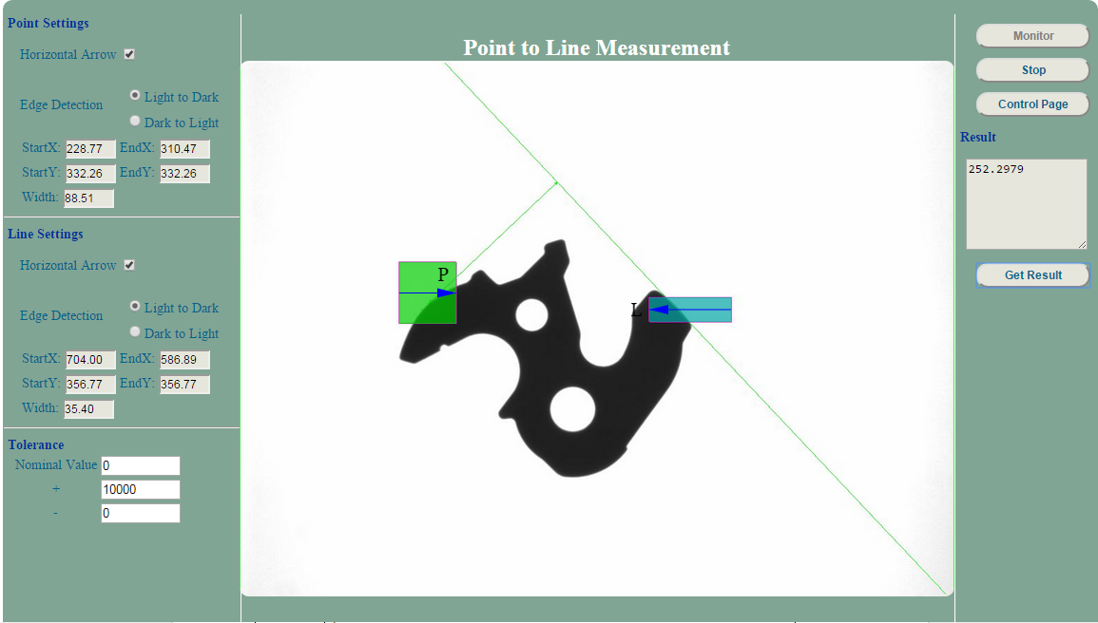

|  |  |
| --- | --- |
| **Number** | **Description** |
| 1 | Adjustment for point settings |
| 2 | Adjustment for line settings. |
| 3 | Above image shows the example to do the measurement from point to line. (Note that the arrow will have to face the direction which wants to measure. Also be make sure that object border line needs to be straight for line ROI.) |

### Width Measurement Page

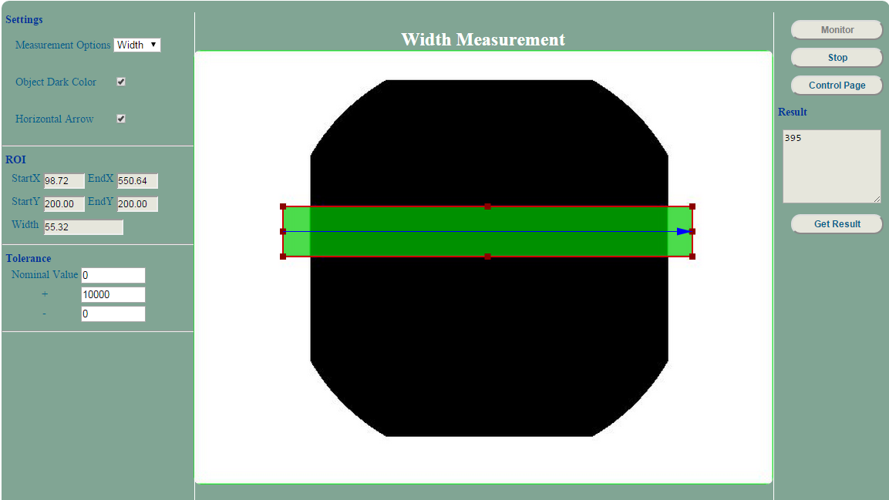

|  |  |
| --- | --- |
| **Number** | **Description** |
| 1 | Adjustment for width settings |
| 2 | Above image shows the example to do the width measurement. (Note that the two lines of object should be parallel.) |

### 